**Left, Right and Full Outer Join**

Left Outer Join

-- It gives us the matching rows and rows which are in the left table but not in the right table.

-- The rows for which there is no matching row on the right side, the result-set will contain null. LEFT JOIN is also known as LEFT OUTER JOIN.

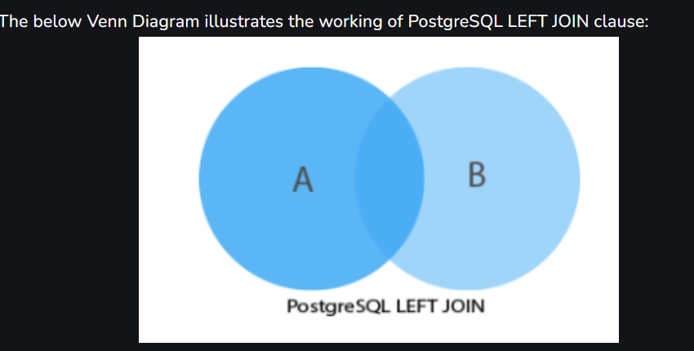

SELECT *

FROM dev_schema.department as dept LEFT OUTER JOIN dev_schema.employee as emp

ON emp.fk_department_id = dept.department_id;

Right Outer Join

-- It gives the matching rows and the rows which are in right table but not in left table.

-- PostgreSQL RIGHT join fetches a complete set of records from the right, with the matching records (depending on the availability) in left. The result is NULL in the left side when no matching will take place.

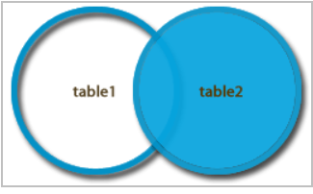

SELECT *

FROM dev_schema.employee as emp RIGHT OUTER JOIN dev_schema.department as dept

ON emp.fk_department_id = dept.department_id;

Full Outer Join

-- The SQL FULL OUTER JOIN statement joins two tables based on a common column. It selects records that have matching values in these columns and the remaining rows from both tables.

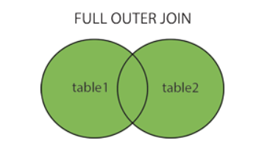

SELECT *

FROM dev_schema.employee as emp Full OUTER JOIN dev_schema.department as dept

ON emp.fk_department_id = dept.department_id;